Cyber Security assignment 2

Jonathan Mitchell

**1.**

**Command to list the updates available:**

**Command used:** apt list --upgradable

**2.**

**Updating and upgrading the system:**

**Command used:** sudo apt update && sudo apt upgrade

**4.**

**Changing current user to root user:**

The command prompt looks a lot different when I am logged in as root. Instead of displaying my normal username mitchellj, it shows that I am logged in as the root user. The hostname still remains the same though. Another difference is the color of the command prompt, instead of appearing in green, the prompt is shown in white like regular text, which makes it stand out from my normal prompt. Finally, the prompt also displays the full path of my current directory, and it ends with the # symbol, further indicating that I am operating as the root user.

**Command used:** sudo su root

**5.**

**Creating bobby and sally using useradd & adduser:**

The difference between useradd and adduser is that useradd simply allowed me to add a user with no extra steps or requirements. adduser on the other hand as you can see in fig 3 above prompted me to enter a password for the user along with other information such as their full name, room number, work phone, home phone, or other.

**6/7.**

**Change User/Create user:**

When I’m logged into to sally, I can see that the username in the command prompt has changed to sally. I can also see that I’m in my home directory instead of Sallys. That’s because I only switched users and not change directories. When I tried creating a new user using useradd and adduser I was given a permission denied or an “ only root user may add a user or a group to the system”. Because sally is just a normal user with no higher permissions she cannot add users.

**Commands used:** useradd adduser

**8.**

I’m a little confused on what you meant by “Delete the user earl since I was not able to create earl as sally, I just got errors.

**9.**

**Password Change:**

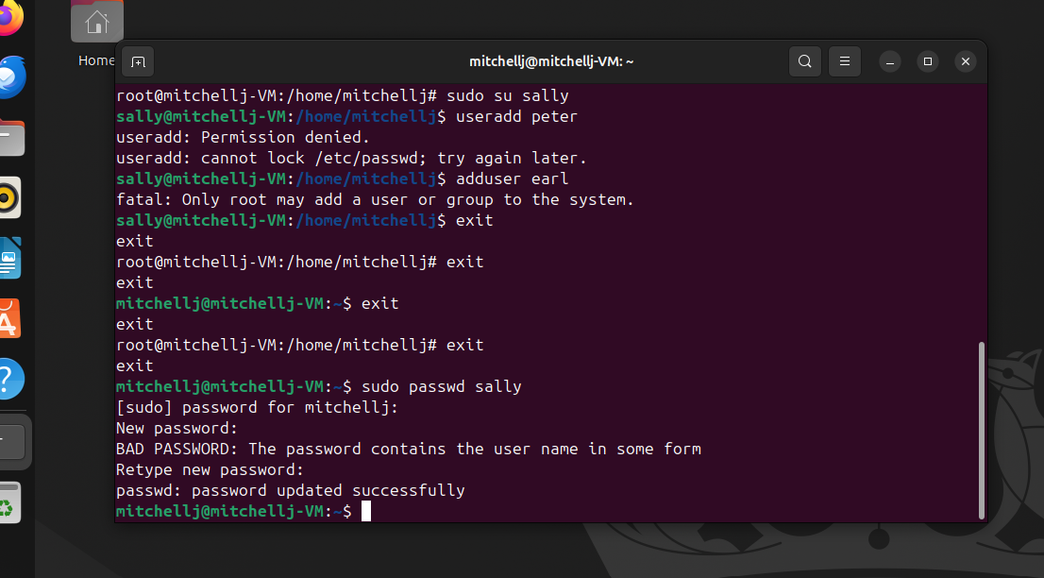

**Commands used:** sudo passwd sally

**11:**

**user id:**

**Commands used:** id

**12.**

I don’t know what you mean by “what groups ubuntu belong to” I tried to do groups ubuntu but it said that user does not exist but then I did mine and it gave me an output. After googling what the results mean I got as follows.

* **Adm**: lets me read system logs.
* **cdrom** : access to CD/DVD devices.
* **Sudo**: allows me to run admin commands with sudo.
* **Dip**: lets me use dial-up/PPP networking.
* **Plugdev**: lets me mount/unmount removable devices without root.
* **Users**: is just a general group for normal users .
* **Lpadmin**: allows me to manage printers.

**Command used:** groups mitchellj

**13.**

**Giving Sally sudo access and creating a new user:**

**Command used:** sudo usermod -aG sudo sally

**14/15/16.**

**Creating the Cybersec group and adding Sally:**

**Commands used:** sudo group add cybersec, sudo usermod -aG cybersec sally, groups sally

**17.**

**Creating lab1 directory and checking ownership:**

**Commands used:** mkdir lab1 ls -la /home/mitchellj/lab1

**18.**

**Creating hello world bash, making it executable then running it:**

**Commands used:** nano helloworld chmod +x helloworld ./helloworld

**Helloworld file:**

**Commands used:** #!/bin/bash echo “hello world”

**19/20/21.**

**Checking permission access:**

The owner has read write and execute permission and it’s the same for the group, other on the other hand only has read and execute permissions. Since the group already has read, write and execute permissions I don’t think I need to give it to them so I’m a bit confused.

**Commands used:** ls -la helloworld getfacl helloworld sudo setfacl -m u:sally:rw helloworld

**Git Hub Repo Link:**